**Gesture Control with Leap Motion**

# Table of Contents

Table of Contents 1

Background 2

Aims and Objectives 3

Literature Review 4

Interface Background 4

Human Computer Interface (HCI) 4

Project Modules 5

Remotely Controlled Device 5

Gesture Controller 6

Project Management 9

References 11

Appendix A (Gantt Chart) 13

# Background

The idea of the research and application of human computer interface is to make the human world and the digital world to come nearer for the cross communication between them. This project revolves around making hand gestures as a means of communication which will result into a definitive, quantitative and measurable difference in the real world with the help of technology. People have been typing and speaking and scrolling on their personal devices for some time now but have been limited to that. A full scale utilization of our abilities and organs is yet to be economically applied. Imagine a world where you can move artifacts with just the ability to think that you are moving it. This is just a step towards the application of that technology for the ease of living. This is the idea of automation, the idea of easier living, the idea of future.

The idea of interacting with the computing systems is fairly new and many changes have come around from the beginning of its era. We have evolved from changing connection wires for different computing option, turning switches ON/OFF to command line processors and then to a graphical user interface. But still, the complete potential hasn’t been utilized for the ease of use of the user to make things work faster and better.

In today’s world, various types of users are there with different needs and demands from the same type of system while the types of interacting devices and media are limited. Limitations have reached where we can just type on the keyboards, slide mouse cursor across the screen, slide fingers on the trackpad and flick them to perform special tasks. A user with more multi-media interests will have applications to edit, produce and publish media while a designer will have applications for their interests in collaboration with designing hardware. The problem arises with many users who are interface oriented and 3-D modelling oriented as the manipulation of drawn objects is time consuming and confusing. A possibility of improvement can here be introduced by usage of a different kind of input device which will be used for object manipulation via the usage of the users’ hands [14] [15].

Hand movement as an input for applications is very unique and helpful in bringing the best creativity and control. They can also be used to interact via holograms, interact with different peripherals and devices and would be a useful tool for designing. A new input method introduces many more options and ways of interacting and opens a door for more immersive experience while using a smart machine.

Thus, in this project, hand gesture recognition and manipulation is performed as a proof of concept and setting up a benchmark for further project to set themselves upon. This project uses a LeapMotion Controller on a network to communicate with a mini-computer, namely a raspberry pi. The raspberry pi will be connected with some hardware such as motors and driven on instruction sent to it.

# Aims and Objectives

The aim of this project is to create a proof of concept for the gesture control with a Leap Motion controller. The project progresses by performing background research on human computer interfaces and their co-relation with leap motion. The main part of the project is to receive data from the controller and display relevant data to the user on a laptop screen. This is done by making specific channels for each type of data set sent from the controller.

The other part of the project is to transfer these controls and instruction set to a remote hardware. The aim is to make the device make movement as per user instructed. Thus, the device configuration is specified accordingly while allowing a 2-way connection so as to provide some sort of feedback to the user. Different movements are to be made by the device thus, different movement need to be quantified. Defining the mechanism of the remote object is also necessary as it would define many aspects of the project including the requirements of the number of input/output pins that need to be kept open for communication between computing device and the mechanical hardware.

Primarily, a simple textual feedback is given to the user to help him identify the gesture being input and recognised by the hardware. The aim of this is to make the user aware of the instructions, which are being made and how are they computed by the software. The future aims would be to develop a 3-dimensional graph which shows live user inputs, analysing the received data and transferring it to raspberry pi, building the hardware for the remote controlled object and writing the software for raspberry to perform on the previously set guidelines.

# Literature Review

## Interface Background

The project started as a raw idea of interfacing between various kind of devices in multiple ways like collection tills at railway stations, touch screen control, holograms, mind control, motion duplication. Each aspect represents a unique and interesting portion of human computer interfacing. Collection tills are an example of embedded systems with the involvement of a thoughtfully provocative user interface for the ease of use. Touch screen controls have recently been introduced in the market for the everyday user and have been proved to be quite efficient as compared to the previous systems available. Application development is a part of the touch screen control, most probably an android system which will be useful and help the user in a task that would require much more complex data instruction set input.

As far as holograms are concerned, they are still in a stage of early research and have not been developed much. Mind control is a fairly advanced segment of human computer interfacing where signals from the mind are decoded to perform specific tasks. The signal input for these systems are taken from the node where these electrical signals are transferred to the muscular system of the body to successfully decode them and then translate them to machine understandable instructions [10] [11]. Much research is being done in this area for physically challenged people so as to make their lives easier but comparing today’s available technology, more years of research would be required to produce something that could be economically marketed. Motion duplication also uses the same concept of mind control and instead of using custom hardware, mimics the movement of the user. These are useful for performing a task via a machine due to either physical inaccessibility of the location or non-hostile environment of the same.

## Human Computer Interface (HCI)

This project though concentrates on another aspect, namely gesture control which also being a new inclusion in the interfacing, still proves to be a lot useful and helpful to the users. Much research is being undertaken in the subject but the practical applications of the same are still limited. There are techniques and algorithms to identify gesture from simple cameras while some special hardware is meant to recognise just human movement and are used as Human Interfacing Devices (HID) [4]. The algorithms are too complex to execute and dedicated hardware is better at handling user input at high performance rates. Embedded software are being designed to extend the applicability to many more areas and aspects of future living.

This interfacing technique is useful for many segments of the users of the society e.g. 3-D designers, visualisation experts and will also set a base for working on the holograms. Its application can be extended to being used in games and making open world areas more enjoyable for the user. Gesture can be used as input in house-held devices as well to perform specific tasks and combined with the home automation systems [7] [8].

## Project Modules

There are two parts of the project, the first being the gesture recognition and the second being the control. The project being a proof of concept, is fairly very new to the research and development phase of gesture recognition. The process of data input from an external input module is fairly complicated. There are a number of imaging devices available in the market which perform almost the same job with some pros and cons in features. Although, the feature variation isn’t much, the variation of cost effectiveness of these modules is a lot.

The modules taken into consideration were the Xbox Kinect sensor, 3-D image sensors and Leap Motion controllers. The Xbox Kinect controller is majorly known for high performance gaming environment application which increases its cost but still if attention to details are paid, the frame rate at which these inputs are taken and processed by the computing device is low. A 3-D sensor gives you the same kind of data set as the Kinect but with 3-D image as an input as well. The difference that majorly arises between these two modules is the area of input and how complex the data set is [9]. The Kinect takes whole body of the user into consideration while a 3-D sensor has a much lower input range but due to application of new framework, costs more. Thus, taking into consideration all the pros and cons of each module, Leap Motion controller was chosen as it was best for the application of concept that is intended [1] [2] [3].

## Remotely Controlled Device

The device that would be controlled via hand gestures is a remote controller car with raspberry pi as the computing and controlling device. The communication between the raspberry pi and the master computing device i.e. the laptop is done on a virtual private network which would be created by a router place on the remote device. The protocol that would be used for communication is ssh i.e. secure shell which will give us root administrator access to the raspberry pi and avoid any hindrance for permissions. A motor controller would also be connected which would be controlling two motors in parallel. Each motor would control the two wheels on either side and give the remote car the capability of turning on spot. The working could be compared to that of a military tank. The motor on the left of the car would control the front left and the back left wheel and the motor on the right of the car would control front right and back right wheel. The wheels and the motor on each side would be connected via a belt and individual control is provided to each motor via the controller. The turning mechanism would thus be made easy, practical and better than a conventional system. For a turning procedure, the instruction set would be sent according to the following rules:

1. Turn left: The left motor would rotate anti-clockwise and the right motor would rotate clockwise.
2. Turn Right: The right motor would rotate anti-clockwise and left motor clockwise.

## Gesture Controller

The controller on the other hand, gives random data sets to the user for which classification has to be done accordingly so as to mark the fingers and thus, gestures that are being captured. The controller is very sensitive to information recording and is accurate to finger movement up to 3mm with a frame capture rate of 200 frames per second. These frames contain data about the position of specific points of the hands and it is these points that we use to define parts of the hands [16]. The relative position of these points is what makes up the gestures that are finally recognised and forwarded to be further processed. The following code snippet explains the data calling from the frames.

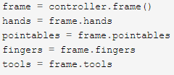

Figure 1: Handler Callback

The hands class returns many values related to hands like its position, palm direction, grab strength, palm velocity, confidence, etc. Pointables refer to objects that can used to point, mainly fingers but can also recognise tools like pencil, pen, etc. The pointables class is rather crude, so to get precise data, fingers and tools classes are used. Each class gives detailed information about the physical object it is representing [17].

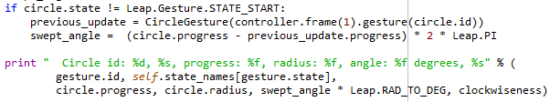

Figure 2: Motion detection

The code snippet above shows the recognition of a circular input gesture made by a finger and tells the direction of rotation as clockwise or anti-clockwise.

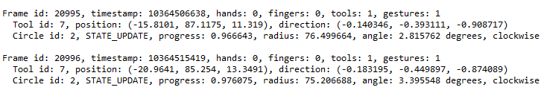

Figure 3: Position of tool in 3-D

This is a run time data showing a clockwise rotation of a tool with position in a 3-D space in x, y and z values, the radius of the circle and the direction of motion of finger.

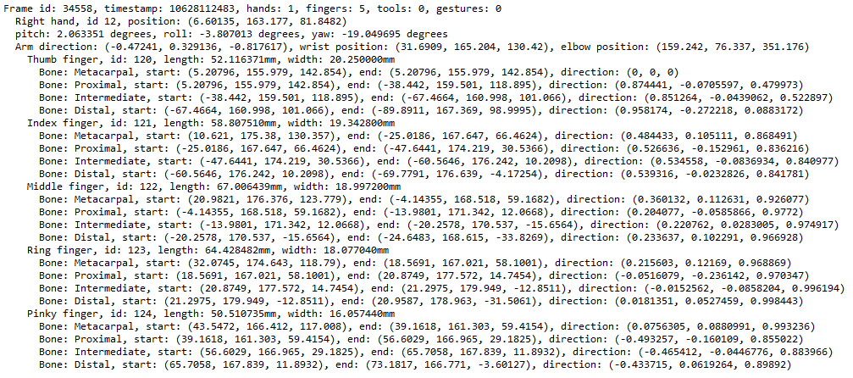

Figure 3: Hand Identification and Position Data

The output snippet above shows the details of all fingers of a hand with their relevant position in the 3-D space and the starting and ending points of bone joints. It also shows the pitch, roll and yaw of the hand and a predicted elbow position. The detailed data can be explained by the figure below with respect to the direction of the controller:

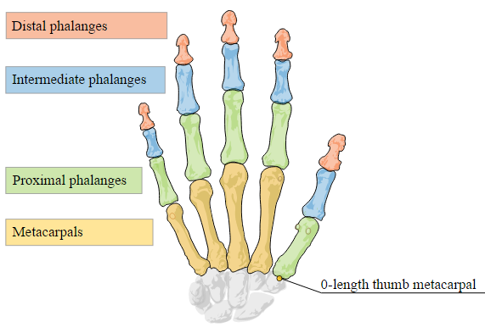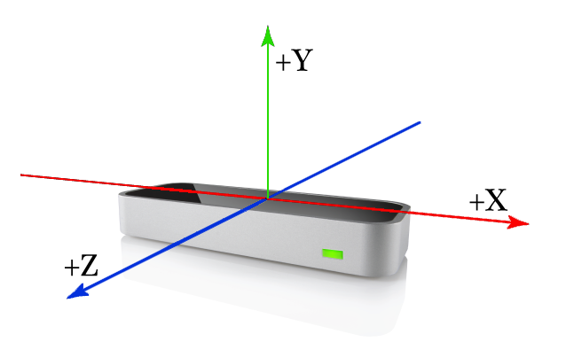

Figure 4: Bone Identification; Leap motion controller and the 3-D axis

The software setup used is based on the python programming language as the classes and the functions called are easier to use. The hardware performs all these tasks with the help of 2 Infra-red cameras and 3 LED lights which help the hardware recognize object and build up data for the same. Many project have been done world-wide with the use of leap motion but none has been set-up to use it so extensively to control another piece of hardware. Continuous developments are being made to the Software Development Kit (SDK) to invite more developers to use their imagination and creativity to develop other multi-purpose hardware [6] [17].

# Project Management

After the submission of the interim report, the following tasks are expected to be done according to the time as mentioned in the updated Gantt chart, which can be found in the appendices of this report:

1. Organising and attending an interview with the second reader
2. Developing a framework for the raspberry pi using the cylon.js module
3. Converting raw data from the controller into 3-D graphical display data for feedback to the user
4. Transferring relevant data to the raspberry pi on a virtual private network while following secure shell protocols
5. Building the hardware for the raspberry pi
6. Putting together all the modules for successful working of the project
7. Testing the project and error correction
8. Completing the final dissertation report
9. Preparing and giving final presentation on the year-long project

**Self-Review**

This project has so far led me to learn skills that are critical like time and cost management, professional conduct, writing a literature report and many more. It has also led me to familiarise myself with technical skills like programming with python, hardware handling, mechanical and electrical compatibility of components, programming with java, network topologies and network framework.

As far as the project progress is concerned, the basic objectives of the project should have been completed while following the time schedule as mentioned in the Gantt chart. The progress made is quite good considering the limitations and the challenges that were faced. Successful extraction of raw data from the controller has been done with the recognition of basic gestures. The raw data is ready to be processed further to be converted into 3-D graphical data. Raspberry pi has been ordered on personal expenses due to limitation of time for a deal that was found on an online portal. The raspberry pi kit also includes tutorial for programming in python and introduction to node.js and cylon.js framework for setting up a project on the raspberry pi.

There has been some issues with funding the project. Since it’s an under-graduate project, and doesn’t have much funding from the department, proceeding with the hardware requirements of this project has been hard. Cost efficiency and cost management has to be considered seriously to fit all the requirements around without having to sacrifice any basic needs for the project to proceed.

# References

[1]C. Manders, F. Farbiz, T. Yin, Y. Miaolong and C. Guan, 'A gesture control system for intuitive 3D interaction with virtual objects', *Comp. Anim. Virtual Worlds*, vol. 21, no. 2, pp. 117-129, 2010.

[2]D. Ionescu, V. Suse, C. Gadea, B. Solomon, B. Ionescu and S. Islam, 'A new infrared 3D camera for Gesture Control', *2013 IEEE International Instrumentation and Measurement Technology Conference (I2MTC)*, 2013.

[3] EETimes, '3-D gesture control breaks out of the game box | EE Times', 2015. [Online]. Available: http://www.eetimes.com/document.asp?doc_id=1266965. [Accessed: 10- Oct- 2015].

[4]V. Vincent, 'Engaging interactivity using gesture control technologies', *2012 IEEE International Games Innovation Conference*, 2012.

[5]M. Alcoverro, X. Suau, J. Morros, A. López-Méndez, A. Gil, J. Ruiz-Hidalgo and J. Casas, 'Gesture control interface for immersive panoramic displays', *Multimed Tools Appl*, vol. 73, no. 1, pp. 491-517, 2013.

[6]G. Marin, F. Dominio and P. Zanuttigh, 'Hand gesture recognition with jointly calibrated Leap Motion and depth sensor', *Multimed Tools Appl*, 2015.

[7]S. Kuchinskas, 'Naked Gaming', *Sci Am*, vol. 302, no. 2, pp. 24-24, 2010.

[8]N. Dardas, J. Silva and A. El Saddik, 'Target-shooting exergame with a hand gesture control',*Multimed Tools Appl*, 2012.

[9]J. Sell and P. O'Connor, 'The Xbox One System on a Chip and Kinect Sensor', *IEEE Micro*, vol. 34, no. 2, pp. 44-53, 2014.

[10]Y. She, Q. Wang, Y. Jia, T. Gu, Q. He and B. Yang, 'A Real-Time Hand Gesture Recognition Approach Based on Motion Features of Feature Points', *2014 IEEE 17th International Conference on Computational Science and Engineering*, 2014.

[11]M. Joshi, V. Sharma and D. Sayleegharge, 'Gesture & Speech Based Appliance Control', *Ijera*, 2014. [Online]. Available: http://www.ijera.com/papers/Vol4_issue1/Version%203/AV4103298302.pdf. [Accessed: 10- Oct- 2015].

[12] Ieeexplore.ieee.org, 'IEEE Xplore Full-Text PDF:', 2015. [Online]. Available: http://ieeexplore.ieee.org/stamp/stamp.jsp?tp=&arnumber=6228574. [Accessed: 10- Oct- 2015].

[13]J. Han and N. Gold, 'Lessons Learned in Exploring the Leap Motion Sensor for Gesture-based Instrument Design', *discovery.ucl.ac.uk*, 2015. [Online]. Available: http://discovery.ucl.ac.uk/1436807/1/Han_Gold_Leap_Motion.pdf. [Accessed: 10- Oct- 2015].

[14]Y. Yin and R. Davis, 'Real-time continuous gesture recognition for natural human-computer interaction', *2014 IEEE Symposium on Visual Languages and Human-Centric Computing (VL/HCC)*, 2014.

[15] Business.highbeam.com, 'Wave Your Hand, Control Your Computer: The Entrepreneurs Behind the Leap Motion Controller | HighBeam Business: Arrive Prepared', 2013. [Online]. Available: http://business.highbeam.com/498/article-1G1-342766291/wave-your-hand-control-your-computer-entrepreneurs. [Accessed: 10- Oct- 2015].

[16]M. Nowicki, O. Pilarczyk, J. Wasikowski and K. Zjawin, 'GESTURE RECOGNITION LIBRARY FOR LEAP MOTION CONTROLLER', 2014.

[17] Developer.leapmotion.com, 'API Overview — Leap Motion Python SDK v2.3 documentation', 2015. [Online]. Available: https://developer.leapmotion.com/documentation/python/devguide/Leap_Overview.html. [Accessed: 04- Dec- 2015].

# Appendix A (Gantt Chart)

